**Final Design Report**

**Filament Recycler**

Group Members: Alec Rich, Connor Cassaro, Jon Bayert,

Paul Oscar Benbow, Munib Rashad, and Nicole Pomeroy

Primary Advisor: Dr. Daniel Blood

Secondary Advisor: Dr. Sami Khorbotly

Course: GE-497

Valparaiso University

Report Submitted on November 17, 2020

The goal of this project is to create a filament recycling system for student and youth groups in a non-profit application. To successfully meet the needs of the customer, the recycler needs to be able to extrude polylactic acid (PLA) within a specified diameter tolerance and have the ability to save preset extrusion settings for PLA. The system will be able to accept multiple input voltages and reach temperatures high enough to melt PLA and other commonly used filament materials. The recycler will be broken up into three subsystems: extrusion, diameter control, and spooling. It should also be noted that the system will meet OSHA and general safety standards to ensure that its operation will not endanger young learners or the user.

**Honor Code Statement**

I have neither given or received, nor have I tolerated other’s use of unauthorized aid.

*Connor Cassaro* *Munib Rashad*

Connor Cassaro Munib Rashad

*Nicole Pomeroy*  Jon Bayert

Nicole Pomeroy Jon Bayert

*Alec Rich*  *Paul Oscar Benbow*

Alec Rich Oscar Benbow

**Table of contents**

Section I - Introduction: **4**

Section II - Problem Definition: **4**

Section III - System Overview: **4**

Section IV - Alternative Solutions Analysis: **5**

Section V - Virtual Prototype: **7**

Extrusion 7

Diameter Control 9

User Interface and Power 10

Spooling Mechanism 11

Section VI - Hazard Analysis:. **11**

Section VII - Requirements Verification: **12**

Section VIII - Personnel Qualifications: **13**

Section IX - Budget: **14**

Section X - Conclusion: **14**

Figures and Tables **16**

References **30**

Appendix A: ASA **31**

Appendix B: Heat Transfer Calculations **32**

Appendix C: SDRD **33**

Appendix D: Mechanical Drawings **35**

Appendix E: Wiring Schematic **36**

Appendix F: UI Operating Procedure **37**

Appendix J: Hazard Analysis **38**

## Section I - Introduction:

A filament recycler is a system that accepts shredded plastic and turns it into filament for 3D printers. The goal of the project is to create an open source filament recycler for educational purposes. The barrel will be wrapped in a wire heater to heat the barrel up to melt the plastic that is being pushed through by the screw from the hopper. It will then be forced through the die and be cooled down so that it can be respooled. Figure 1 shows a model of what the entire design should look like. The filament recycler is a way to teach kids about recycling and also help the schools and libraries keep costs down by not having to purchase new filament. This report will go into detail on all the work that has been done thus far and why it has been done for the project. The following report will lay out the problem that the design will fix, give an overview of the entire system, detail what has been virtually prototyped, and go over the budget for the project.

## **Section II -** Problem Definition**:**

The reason for creating this filament recycler for the customer is that he wants to show kids that they can take their old or messed up prints and recycle them into new filament for them to use again and create more prints. It is estimated that in 2020 there will be 8 million kilograms of waste created through 3D printers, the biggest causes being test prints, old prototypes, supports, and failed prints [1]. This waste can be represented by 200 million dollars just in 2020 alone. The customer has requested this filament recycler because the other similar products on the market that he had been looking at cost in the range of $5,000 to $8,000. He wants something that will be educational and still cost less. Some problems include that the design must be safe for kids to be around. This means that outside surface temperatures should be limited so that anyone who comes into contact with it will not be burned. Likewise, there cannot be any moving parts exposed to prevent someone from being harmed should they reach into the system. Since this will be educational, the customer will likely be transporting the system to schools and libraries, therefore it leads to having to minimize weight and size where necessary. The biggest challenge is making sure that the filament is extruded within the tolerance of 1.75 ± 0.05 mm. If the filament comes out of tolerance, the filament will not be usable for printing and would likely be shredded and run through the extruder again.

## **Section III - System Overview:**

The goal of the system is to get one kilogram filament spools from ground up filament that can be used by fused filament fabrication/fused deposition modeling 3D printers. The system can be divided into three major subsystems: the extrusion, the diameter control, and the spooling mechanism.

The extrusion subsystem is where the system will take ground up plastic, melt it down, extrude it into 1.75 mm filament and cool it down. Ground up recycled filament and virgin filament will be added to the system via the hopper, which will be attached on the top of the heated barrel. A screw will be in the barrel and will be attached to a DC motor with a coupler. The motor will rotate the screw and move filament towards the extrusion die. Right now, the primary focus of the system is to be capable of recycling PLA. PLA melts somewhere in between 130 and 180℃ [2]. A cable heater will be wrapped around the barrel which will raise the temperature of the stainless steel barrel to 180℃. The heater will be capable of raising the temperature of the barrel to 260℃ so that the system will be able to recycle plastics other than PLA [3]. The ground up filament will get melted as it moves along in the heated barrel. PLA is a polymer, therefore doesn’t turn into liquid once its melting point is reached and takes a viscous form. By the time ground up filament reaches the extrusion die, it will be viscous and ready to be extruded into filament.

There is a deadzone within the barrel in between the extrusion die and the screw. This dead zone will act as a small storage and help raise the pressure in the barrel. Once the dead zone is full, the pressure will build up and push viscous filament out of the extrusion die. Filament will come out of the extrusion die in the form of continuous filament strands that are expected to have a diameter of 1.75 mm. As soon as the filament leaves the extrusion die, with the help of fans (forced convection), the filament will be cooled down so it does not deform. The extrusion is complete.

The diameter control subsystem will be used to ensure that the extruded filament remains within a given tolerance range; for the die that the current design is using, this will be 1.75 ± 0.05 mm. After exiting the barrel and cooling, the filament will be fed through a pair of diameter sensors which will continually measure its diameter. The first sensor is a UV micrometer which can measure the diameter based on the light output shining on the opposite side of the filament without contact. The second sensor is an incorporated dial indicator with a digital output that contacts the filament as it extrudes. It will then be put between a pair of rollers mounted on servo motors which will apply tension to the filament and pull it through the system. Should the diameter fall outside of the desired tolerance range, the rollers will adjust the tension applied to the filament accordingly so that the diameter remains within the tolerance.

The final subsystem of the filament recycler is the spooling mechanism. Once the filament has passed through the micrometer and dial indicator, it will have to be manually attached to the spooler at the end of the system. After being attached, a servo motor will begin to rotate the spool such that the filament is wound around it. A light sensor will be present on the spool shaft to measure its speed of rotation, which will be automatically adjusted by the microcontroller to ensure that it is not turning too quickly compared to the rate of filament output. A weight sensor will be present beneath the entire subsystem to measure the weight of the filament on the spool and display it on the user interface. Once the spool has nominally 1 kg of filament on it the system will stop. The spool of filament will be able to be detached and used in a 3D printer.

## **Section IV - Alternative Solutions Analysis:**

Due to the open ended nature of this project, a number of solutions were presented to accomplish the goal of controlled plastic extrusion. Most significantly, there were options for the system orientation, heating element, motors, and filament diameter control. To move forward with the best choice, an alternative solutions analysis (ASA) was implemented. Using this method of ASA, group think was avoided, and all team members were able to get an equal input regardless of their level of comfort of group communication or presentation. The results of each ASA can be seen below and numerically in Appendix A.

**System Orientation -** Initially there was a question of whether utilizing the natural gravitational force acting on the filament to apply tension would be favorable to using a more common horizontal orientation. While gravity would have an option to remove some of the work that tension servos would require, the additional work in creating a raised support for the extrusion system as well as angled hopper mount did not seem economical. For similar reasons, a downward angle orientation was also deemed to be more complex than necessary or worthwhile and a simple horizontal approach would be chosen to proceed with design.

**Heating Element -** Initial thoughts for heating the barrel to 180°C were that a series of band heaters would be implemented. This option would allow for simple clamp on heating applications with the option for motion along the barrel to optimize filament extrusion. Through research in alternative options, a wire heater was also found for consideration. The wire heater would only require one instance of purchase and installation and had overall more surface area coverage and mobility along the barrel. It was also discovered that band heaters would not be able to fit the specific barrel size designed by precious plastics that would be used in this project. Following this chain of thought, a wire heater was chosen for this project application.

**Filament Diameter Control -** In this section, two important design considerations were met. The first covered the physical means of controlling filament diameter and the second was the control loop that would communicate with our means of control to keep the filament in tolerance. In the first decision, tension, heat control, and screw speed were compared. Heat control was ruled out due to concerns over lack of reaction speed and risk of burning or over melting the plastic. The screw speed alone was still a major question of torque and control but enough was known that this option was too heavy handed for delicate control of .05mm. Applying tension using a servo motor was determined to be the best option to use for the design due to the precise control of torque that it has. This motor was decided to be separate from the spooling motor which would change torque whenever the radius of the spool changed, which is constant as filament wraps around the spool. The final decision became that it would be a combination of screw speed to control system mass flow and a servo tensioner to control the output of the mass flow.

To determine when the changes of the control applications mentioned above would occur, a decision had to be made on what sensors would be put in place. Initially, most commercial sensors for the resolution desired were ruled out due to cost. This meant that most optical and laser micrometers were not considered due to budget. A design that utilized magnetic attraction on either side of the filament seemed favorable and easily manufactured but was also ruled out because of the proximity to the exit being heated and potentially altering the magnetic force enough to knock our system out of calibration. With further concerns regarding optical sensors beyond cost such as complexity and resolution, a modification to digital calipers became an inhouse manufacturing option that met the resolution the project required.

**Motors -** After the initial design was drawn up, it was decided that three motors would be implemented. The first motor will rotate the screw component in the barrel and would require an unknown amount of torque. The second two run similar applications of spooling and tensioning the filament as mentioned above. It was easily decided that servo motors can meet the light loads at the end of the process and could change applied torque easily. The primary motor was more difficult to come to a decision on with the option of AC or DC and the overall power that was estimated to be required. After some research, it was also found that motors were available within the manufacturing lab on campus and that a geared down DC motor would be the best option with the unknowns in torque being such a large problem in this decision.

## **Section V - Virtual Prototype:**

### Extrusion

**Screw and Barrel -** These components are designed by Precious Plastic and manufactured by Robotdigg according to the schematic shown in Figures 2 and 3. While not shown in the diagram, an uncommon threading on the end of the barrel which is not used in the end product of the filament recycler. The screw and barrel are used together to press melted plastic through an isolated system by having tight tolerances to each other and a taper on the screw.

Constraints on use of this part will involve minimizing modification of this pair of components so that the length and diameter tolerances are not altered. This pair in turn restrains the project by its threading and natural dimensions; nozzles of 1.3in diameter with ~11 threads per inch would be costly to manufacture and are not commonly sold.

**Coupler and Motor -** The screw for this system comes standard with a hexagonal cross section that is 0.5in in size. To connect to the motor axle chosen for this project, a flex coupler will be used to accept the hexagon screw end to the desired motor output. Specifically, for this project, a Leeson 1/3hp DC motor was used. This motor will handle the bulk of the torque required to push plastic through the pressurized barrel. The resulting coupler made is displayed below in Figure 4. The flex coupler will be constrained by material strength as high torque is applied from the motor to turn high pressure melted plastic. Since the motor shaft is keyed and the screw has a hexagonal shaft there needed to be some manufacturing involved. A hex socket was welded to a 1in diameter rod that had a slot machined into it for a key to be inserted to lock it into the coupler. This was to ensure that the rod could be put into the coupler to accept the screw into it. Size will also come into play due to the motor height off of the ground, so increasing the area will have its limitations.

There will be a photo interrupt to calculate rotations of the screw motor. Every time the screw rotates, an indicator will pass through the photo interrupt, the system will be able to count the number of revolutions that the barrel completes.

**Support Structure -** This bolted assembly will hold the different processes at certain points to better keep tolerance and optimize cooling to size for the system and can be seen in figure 5. It will also be used to raise the screw and barrel up to the height of the motor output so that the screw and barrel have their respective axis of rotation collinear. This will prevent part wear from the screw scraping against the barrel.

Support structure dimensions will be constrained by the height of the Leeson motor output, barrel geometry, and cooling necessities. The support needs to be able to hold the barrel by its premanufactured bolt holes without causing the screw to scrape along the side, as well as provide enough time for fans to cool the filament before rolling tension is applied.

**Barrel Flange and Die -** It was determined that creating an external flange and die would be best for the scope of this project due to the ease of modification, maintenance, and complexity of thread based nozzle production. This component will reduce the flow of melted plastic through a 1.75 mm diameter die that is a separate component from the external end cap. The purpose is to create correctly sized filament and to have a part that if worn out would be as easy to replace as a filter. Individual parts are shown in Figures 6, 7 and 8 and can be seen assembled in Figure 1.

The flange itself is constrained by the given barrel diameter and the die must output 1.75 ± 0.05mm while fitting in the cavity between flange plates. It should also be noted that the flange is made out of stainless steel so that it could be welded to the barrel in order for the die components to be bolted against it to withstand the pressures associated with the extrusion process.

**Insulation -** As part of the safety protocols, insulation will be applied along the length of the barrel to reduce the temperatures from as high as 300°C down to 49°C. For this purpose, 1.5in fiberglass insulation is being used. If the insulation fails to reduce the barrel temperature to 49°C, a cage will surround the system so that it cannot be touched by bare skin. If other components of the system break 49°C through conduction, more insulation will be required to cover the system.

At a 180℃ filament temperature assuming the full 500W of the heater is applied, a temperature of 50°C is achieved but is expected to be less. More details on this calculation can be seen in Appendix B.

The safety constraint for this system is that 49°C will require several minutes to apply a burn, it would not be an accident if one got burned at this temperature [4]. However, if failure to create a system of this temperature as the system is active, a more instantaneous burn threat will be in play that could place children using the recycler at risk of injury.

**Heater -** The heater component for this project is a wire heater that will wrap around the barrel and is adjustable such that it could be grouped tighter to produce more heat to the plastic. The heater will be controlled with a Dwyer series 16B 1/16 DIN controller and has a maximum output of 500W. The controller will be connected to a thermocouple and the heater. This will use a PID loop to precisely control the temperature of the filament. In addition, the temperature can be set from the arduino. This will communicate over modbus to the arduino using a custom shield.

Heating of the plastic is constrained by motor speed and plastic properties. It is not desirable for plastic to be too hot thus causing damage to the plastic itself or it will ooze out of the extruder. Through testing, a resulting calibration relationship between screw speed and temperature will be developed, but for now a known design constraint is that PLA will melt between 130-180 ± 2.5°C.

**Hopper -** Plastic enters the system through the hopper, which is essentially a waiting room for plastic to sit in and wait for processing. The customer has already purchased a grinder so this system will only accept ground up or virgin plastic into the hopper.

While a hopper is a simple project, it must fit well into physical constraints, system requirements, and safety regulations. The barrel component designed by Precious Plastic holds a certain angle and opening to support specific hopper openings which can be seen in Figure 9. An insulation layer between the hopper and barrel connection is being utilized as to prevent significant heat transfer to the hopper. To ensure that a full 1kg spool can be created from a load of plastic, 1 kg of plastic should be able to fit in the hopper in one fill. Lastly, as per Table O-10 of OSHA 29 CFR 1910.217(c)(2)(i)(a) and 1910.217(c)(2)(i)(b), the hopper will be equipped with a safety mesh that will allow .7mm plastic shreddings and not fingers to pass into the screw at the bottom of the hopper.

### Diameter Control

**Roller Assembly -** Controlling the filament diameter with immediate reaction based on a control loop would be most easily accomplished by using applied tension. The roller assembly was found to be the most adequate option for this purpose and consists of rollers, axles, and its own individual housing shown in Figure 10.

To define the assembly, the housing must put the rollers at the same height of the filament so that there is no additional tension from gravity pulling in either direction. The rollers must also be correctly spaced so that they provide tension but do not crush the filament out of tolerance. A final consideration would be if the housing can hold a Hitech 6VDC servo motor in line with a roller axle so no angled stress is applied. A servo motor will give us PWM control over the speed. This will be integrated into the control loop as shown in Figure 11. The servos are beneficial because there is a built in controller, so it enables control of the motors using PWM.

**Sensor -** To measure the diameter of the filament there will be two sensors to provide redundancy to the system. Optimization is desired for two quantities: precision and delay. It is important to get readings that are as precise as possible. Our goal is an accuracy of 0.001mm. However, many of these sensors will require rollers to make contact with the filament. So these sensors have to be kept distanced from the nozzle so that the filament can be cooled down. As the filament comes out of the nozzle it is wanted to be able to get a reading as soon as possible, so that the design can adjust for errors as soon as possible. Thus, there will also be a non-contact light sensor to take readings quicker but with less accuracy. Although it is possible to use a laser sensor, these have prices upwards of around $500, so it would not fit within the budget.

The first sensor will be built using a dial indicator as its basis. This will have a precision of 0.001 mm for about $50. However, due to the fact that it has to make contact with the filament, the sensor will be a distance away from the nozzle to give time for the filament to cool down. This will be connected as seen in Figure 12.

The second sensor is a non-contact light sensor. The filament will pass through this sensor and have a light shone over it. The filament’s shadow will be detected by a light array with 146 pixels. The diameter will be calculated based on the size of the shadow. This sensor can be positioned a few inches away from the nozzle to get prompt results. These two sensors will give quick results and precise results.

The control loop will be a PI controller from Figure 11. The diameter of the light sensor will be output into the system and the PI controller will determine the duty cycle of the PWM.

**Fans -** There will be a fan to cool down the filament after it is extruded. As soon as the filament exits the system, there will be a fan to help cool the filament so that it will not be deformed when being interacted with by the rest of the system. It should be noted that since the system is designed for use on multiple plastics, distances and cooling times aren’t set. The distance for the preset for PLA will be determined through experimentation. The fan will be capable of being turned on and off from the arduino.

### User Interface and Power

**User Interface -** There will be a centralized user interface so that the user can control the system. The user interface will have a button and a knob. There will be a menu that the user can adjust the flow rate of the system, the temperature of the barrel and the PI loop, among other things. The entire system will be able to be controlled from a centralized UI.

There will also be an expedited process where the user can select from several presets. So if the user wants to extrude a specific plastic, the user can press a single button and start running the machine without having to manually adjust the settings.

**Presets -** There will default settings that are stored in the system. These will be easy to use, so that the user can get the system running as quickly as possible. There will be a single button that the user can press to start printing. This will set all the settings to their ideal value and then start the extrusion.

**Printed Circuit Boards (PCBs) -** This design will have two custom PCBs. (See Figure 13) The first is a shield for the arduino. This will include connections for the following components:

* MODBUS to Heater controller
* I2C to UI
* Analog signal to the Speed controller
* Light array sensor digital input
* Dial indicator digital input
* 5V signal to the fan
* 2x Input for the photo interrupt
* 2x servo PWM outputs.

The next PCB is for the user interface. This will be able to communicate with the main board over I2C. The LCD can then be moved around on the system or extended past a safety screen. This allows people to stand back out of the way and still control the system.

**AC to DC Converter -** There are two converters. The first converter takes 120VAC and converts it to 24VDC. The heater uses AC voltage while the barrel motor uses 24V. But many of the sensors use 5V, so there is a second converter that converts 24VDC to 5VDC. This way the arduino and other sensors can run off 5V.

An optional feature will be a converter from 210VAC to 120VAC. This will allow connection to 210VAC as is needed in certain industrial situations.

**Emergency Stop -** There is a large red emergency stop button. This will cut power to the system in case there is an emergency. This is an important safety precaution and is needed in case there are any short circuits.

### **Spooling M**e**chanism**

**Spooler Assembly -** The final step in this process would be to wind the extruded filament onto a standard 1kg spool. To ensure that the filament winds relatively tight and holds approximately 1kg of PLA filament, the spooler will consist of a second Hitech 6VDC servo motor that will wind the spool while sitting on a load cell force sensor that will serve as a scale. The basic concept can be seen as component 12 in Figure 1 where a 1kg spool is mounted to a structure powered by a second Hitech 6VDC motor and will be placed on a scale.

The constraint will be that the servo should not be stronger than the roller servo as that would provide more tension and cause additional deformation. The spooler scale should also be able to withstand the weight of a full 1kg spool and servo motor, while still accurately reading the weight of this system.

## **Section VI - Hazard Analysis:**.

A failure mode and effects analysis (FMEA) was done to determine where the most concerning failures would be within the system. The team looked at 5 separate components within the whole system to determine what the biggest potential failure would be for each component. The 5 components were the heater, spooling, extrusion, screw motor, and sensor. To do the analysis, the team layed out any potential failures that could happen, then looked at the effects of those failures and scored the severity from 1 to 10, and then did the same scoring system for the probability of any potential causes that could lead to the failure. The same was done for how likely it would be to detect the cause. A risk priority number (RPN) was calculated by multiplying together the values for severity, probability, and detection.

For the heater, the failure with the highest RPN was the barrel not getting hot enough. This failure got an RPN value of 204 because it could cause the plastic to not melt and thus be unable to be extruded, which would be considered a failure of the entire system. This issue could be caused by a faulty heater or the thermocouples giving incorrect temperature readings.

For the spooler, the highest RPN associated with it was 155, which was the case of the spooler rotating too quickly. This received a high score because it could lead to the filament being outside of tolerance or even breaking, as the increased spooler speed could apply greater tension to the filament. It is thought that this failure would be due to the motor of the spooler not being in sync with the motor attached to the rollers.

With the extrusion, it was determined that the barrel getting clogged would be the worst with an RPN of 190. The effects of this is that it could cause damage to the system and not extrude plastic. Some causes are thought to be plastic that was received to be put into the extruder could have contaminants in it. Contaminants have the capability of causing large amounts of damage to the barrel as metal pieces could scrape the surface of the barrel, a large contaminant could jam the screw and burn up the motor, and if the contaminant made it to the end of the barrel while also being large enough, it could plug the die and cause large amounts of pressure to build up in the die which could lead to catastrophic failure. To reduce the chance of this hazard happening, the design has some precautions put into place. The customer has informed us that he took a very strong magnet and moved it throughout the plastic that he provided to us to be able to catch any metal pieces. Before the material enters the barrel, it will pass through a mesh that will filter out all larger pieces of material, be it plastic or potential contaminants that could jam the device or scrape the inside of the barrel. If a small piece of contaminant gets into the device it could plug the die thus causing failure. If this were to occur in this design, the team has built in an emergency stop that could be hit to cut power to the system so that no damage could be caused. The team also designed the die to be easily removed for cleaning or replacement.

The motor is where the team had less concern out of the 5 different components. This is because the highest RPN value was 107 for the motor not having enough torque to turn the screw. This could cause the motor to heat up and potentially not work. However, this could be easily detected and it would just mean the motor being used is not correct for the system and should be replaced.

The last component considered was the sensors and it was determined that the diameter sensors breaking would be the worst thing to happen within the sensors. This received a RPN of 140. If the diameter sensor were to break there would be no feedback in the control loop. This could lead to the filament falling out of tolerance making the filament not usable. Since the system will have preset settings it should be able to remain relatively close to tolerance.

## **Section VII - Requirements Verification:**

The first requirement that the system must meet is being able to use an input between 95-125VAC or 195-255VAC at 60Hz as stated in Requirement 1.1 of the System Design Requirements Document (See Appendix C for full SDRD). This is being achieved by using an AC/DC converter that can accept both voltage inputs. The design meets requirement 2.1 of the SDRD by not having an overall size larger than 82 inches by 50 inches by 46 inches. Requirement 2.2 is that the system will have an in-house sensor to measure the output filament diameter and as discussed previously, the system will have two different sensors to ensure that the filament remains within tolerance as needed for Requirement 3.2. The heater controllers used in this design have an accuracy of +/-0.25% span and a feedback loop with a thermocouple will be used to ensure that Requirement 3.1 is met by the system maintaining a temperature accuracy of ±2.5℃ from the set value. The controllers are also manually adjustable thus meeting Requirement 5.2 that the system shall allow for manual temperature control between 130 and 180℃. An additional feedback loop will be used with the spooling mechanism that spools the extruded plastic onto a spool; pressure sensors under the spooling mechanism will stop the system when the spool reaches 1kg of plastic and this will meet Requirement 3.3. In the design a mesh will be located in the top of the hopper as discussed in the hazard analysis section of this report to ensure that no piece of plastic with a dimension exceeding 7mm will be accepted into the barrel as stated in Requirement 3.4. Also, the mesh allows the system to meet requirement 4.4 as it makes the system compliant with an OSHA requirement that no opening is large enough for your hand to get in. The designated motor, gearbox, and speed controller will allow the screw to have a max speed that is more than fast enough to achieve the extrusion rate of 0.2 kg per hour needed for Requirement 3.5. Additionally the speed controller meets Requirement 5.3 of allowing the flow rate to be controllable between 0.1kg and 0.2kg. When it comes to the safety section of the SDRD, Requirements 4.1 and 4.2 are being met with the insulation of an emergency stop button that will cut power to the system and stop all moving components within 5 seconds. Lastly for safety the insulation that was chosen was 1.5in thick around the barrel so that it will meet requirement 4.3 that external surfaces that can be touched will not exceed temperatures of 49℃. Within the code of the project there will be preset settings that will be maintained even with power loss to the system as specified by Requirement 5.1. The user interface will also have an LCD screen to display the values for the temperature of the barrel as measured by a thermocouple to satisfy Requirement 5.4. Currently the budget for the design is coming in at $2025.85 which is largely under Requirement 6.1’s budget limitation of $5000. Lastly, all documentation that has been created throughout the design of this design has been properly named and organized within a google drive so that all documentation will be complete for Requirements 7.1-7.5.

## Section VIII - Personnel Qualifications:

Connor Cassaro - Chief Executive Officer:

Connor has taken classes and has experience with SolidWorks and manufacturing labs. This will help make sure everything is modeled and drawn correctly. His experience with classes such as heat transfer will help ensure heat requirements are met. Connor has experience with injection molding through internships where his knowledge will aid in the extrusion part of this project.

Munib Rashad - Chief Operations Officer:

Munib has completed three semesters of research at Valparaiso University College of Engineering which has given him extensive knowledge of designing and rapid prototyping. He has also taken manufacturing lab course and has used the manufacturing lab frequently for his research which gives him good command on the manufacturing processes. This experience will help with the manufacturing side of the project and properly documenting it. Also, will help ensure that all parts of the project have correct and complete mechanical drawings available. Furthermore he has gained project management experience from his current internship which will help to keep the project on track and deal with the issues that the team face throughout the development phase.

Nicole Pomeroy - Chief Financial Officer:

Nicole has had a lot of experience with CAD modeling as she has been using various 3D modeling softwares for almost 10 years. She spent two summers working exclusively in Solidworks modeling parts and redesigning 100+ part assemblies; this experience will ensure that parts are designed and documented thoroughly. She also spent an additional summer as a manufacturing engineer designing and making fixtures for a manufacturing line so she has experience working on a project from planning all the way through implementation. This experience will aid in helping keep the project on track for completion.

Jon Bayert - Chief Technology Officer for Electrical and Computer Engineering:

Jon has taken classes with circuit and PCB design and has built several PCBs. This will help make sure the circuit is safe and the board is designed cleanly. He also has experience in embedded systems at Caterpillar so that will ensure that system is assembled correctly.

Alec Rich - Chief Technical Officer for Mechanical Engineering:

Alec has nearly 4 years of experience in 3D CAD modeling, 3D printing, and project assembly. As the project manager of the power wheels project for the ASME chapter of Valparaiso University, he has experience in cost effective and functional design through custom metal working and wiring. Knowledge on heat transfer and material science are additionally applicable for this project for the design phases of development.

Oscar Benbow - Chief Communications Officer and Chief Administration Officer:

Oscar has experience in arduino programming as well as PCB and circuit design. He has interfaced with microcontrollers, LCDs, and various sensors before, and also has built some larger circuits. This experience will ensure that he can verify that all of the electrical components of the design are correctly assembled.

## **Section I**X **- Budget:**

The budget that was provided for this project was $5,000. There are numerous different parts that need to be purchased to make the filament extruder system and all parts have been listed in Table 1 in the Figures and Tables section of the report. In the bill of materials, the components have been broken down into 3 categories: electrical components, structural components, and other additional components. The first category, electrical components, is by far the largest and most expensive category. The total cost of all of the electrical components is $1,747.95 and well over half of this price is made up of the motor and gearbox needed to turn the screw. The next section is the structural components like the screw, barrel, and stock material needed to make the in house manufactured parts; this category costs $250.06. The final category in the bill of materials is just additional components that are needed for the design, such as the insulation and this category comes in at $27.84. The total cost of all components sums up to $2025.85.

## **Section** X **- Conclusion:**

The goal of this project is to create a system to recycle used filament for student and youth groups in a non-profit application under a budget of $5,000. To successfully meet the needs of the customer, the recycler needs to be able to extrude PLA with a diameter tolerance of 1.75 ± 0.05mm, with the ability to save presets using a closed control loop. The system will be able to accept multiple input voltages and reach up to 260°C with a 2.5°C tolerance as laid out in the system design requirements. The recycler will be broken up into three subsystems: extrusion, diameter control, and spooling.

The total cost of the recycler is estimated to be $2025.85, meeting the customer’s cost requirements. The filament diameter and temperature are anticipated to meet expectations due to the reliability of the component sources and calculations. An adapter for the power input will ensure that regardless of power source used, the recycler can be simply plugged in without further problems. Safety within the recycler prevents extremities from burning and crushing using insulation and hopper precautions.

The design will be open source thus meaning that all aspects of the design will be thoroughly documented and available to the public. As a result of this documentation the design will be easily modifiable long term and will allow any user to customize the design to their own liking. Additionally because it was designed to be open source, the easily accessible components picked makes maintaining the system long term simple and straightforward.

## Figures and Tables

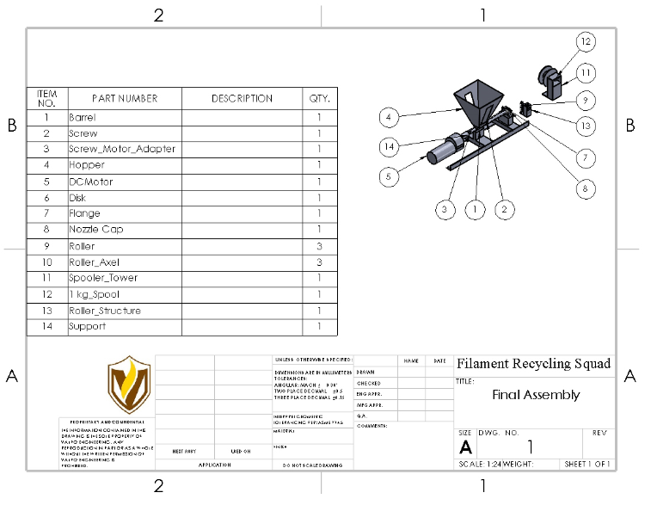

**Figure 1**. Drawing for the final system assembly

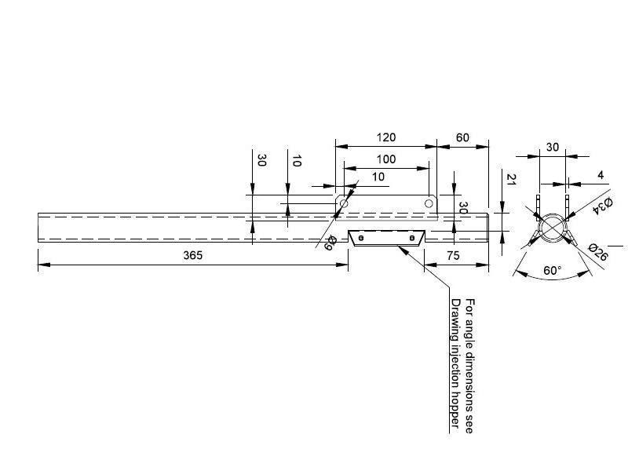

**Figure 2**. Drawing of the barrel from Precious Plastic [2]

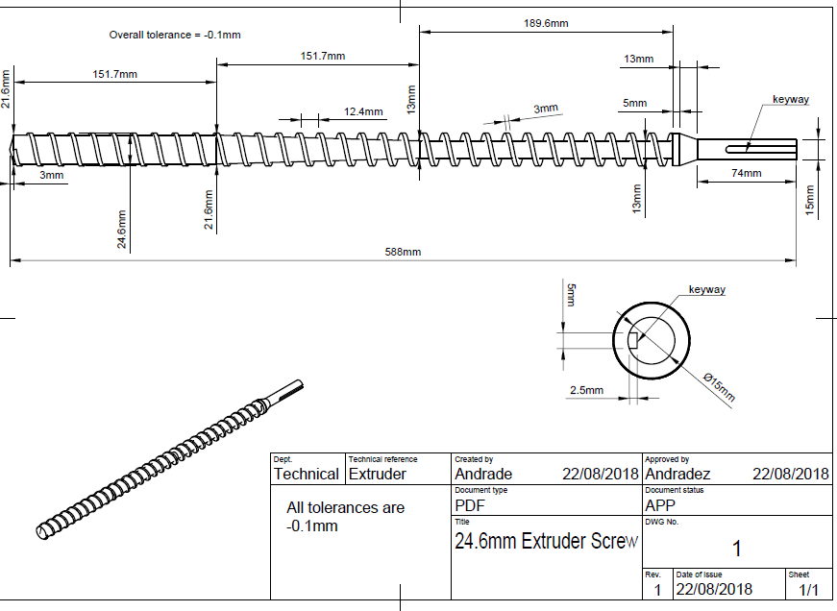

**Figure 3**. Drawing for the screw from Precious Plastic [2]

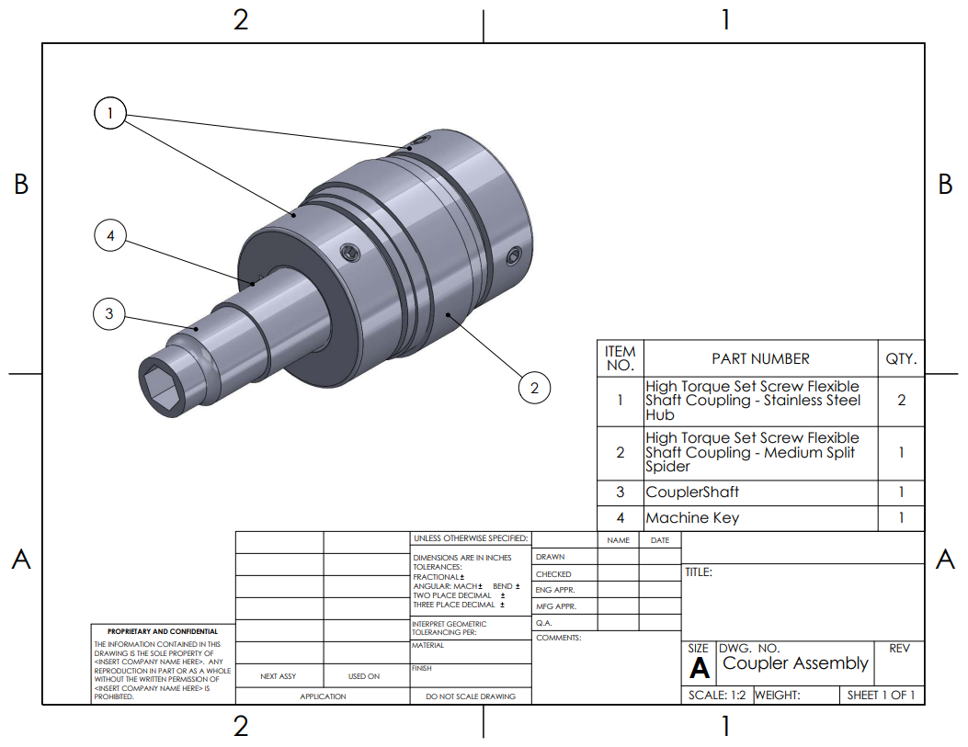**Figure 4**. Drawing for the coupler assembly between the screw and motor shaft

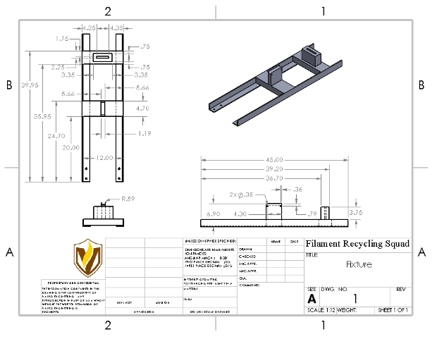

**Figure 5**. Drawing for the fixture that the barrel and motor will be mounted on.

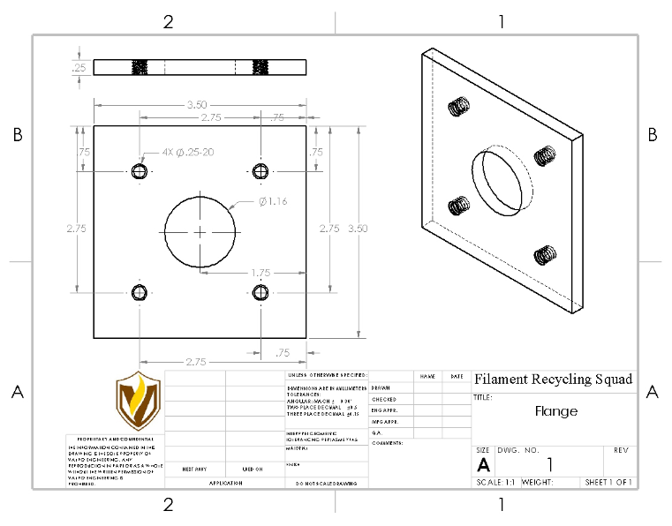

**Figure 6.** Drawing for the flange

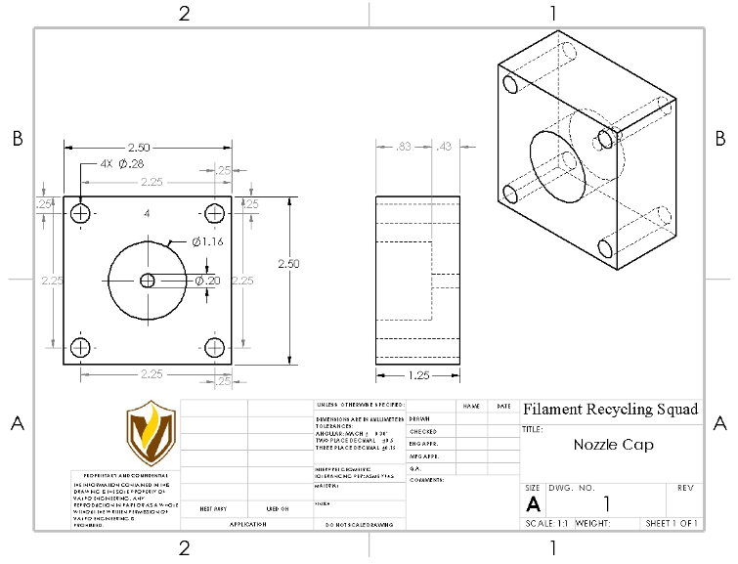

**Figure 7**. Drawing for the nozzle cap

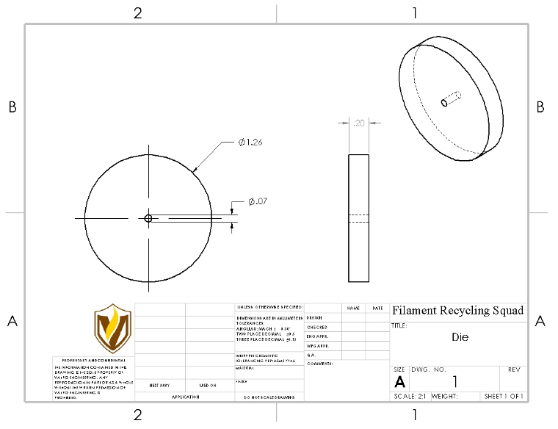

**Figure 8.** Drawing for the extrusion die

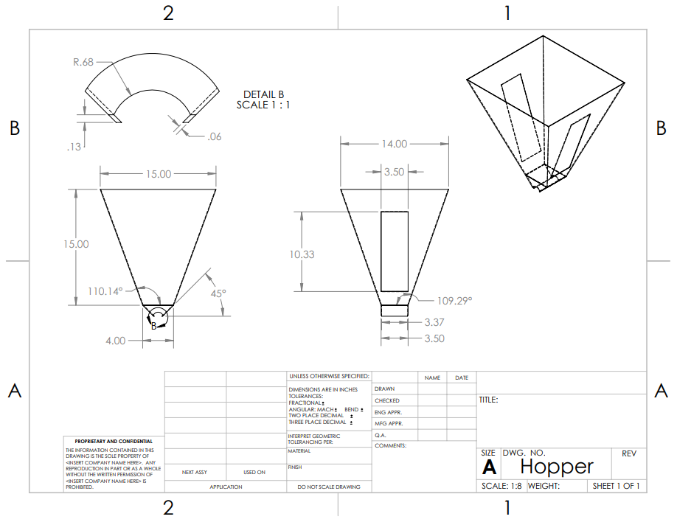

**Figure 9.** Drawing for the hopper

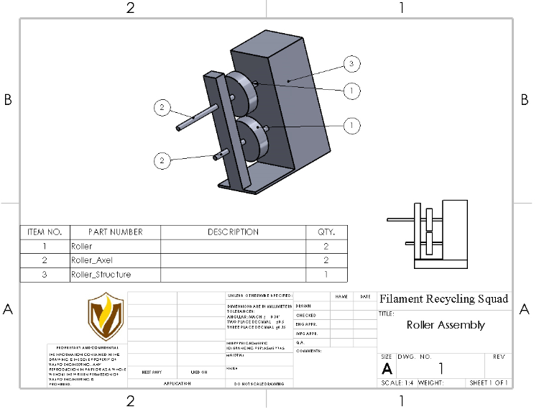

**Figure 10.** Roller assembly

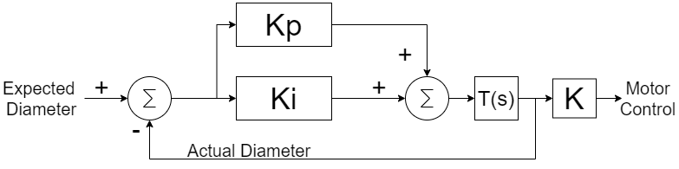

**Figure 11. The control system for the diameter**

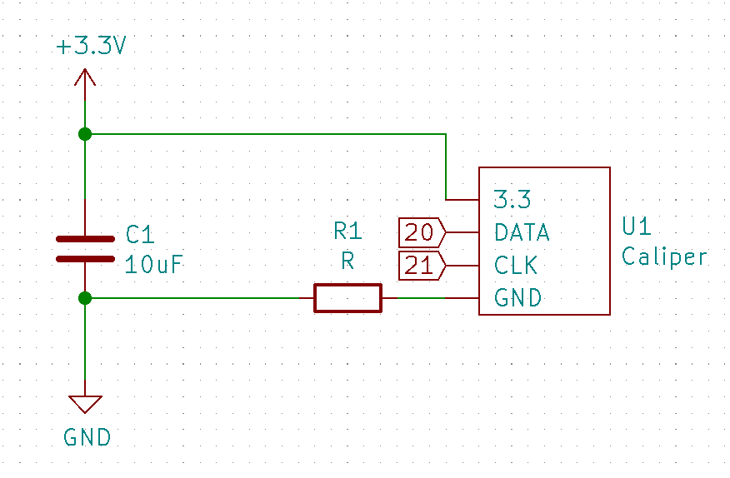

**Figure 12. The link for the Caliper**

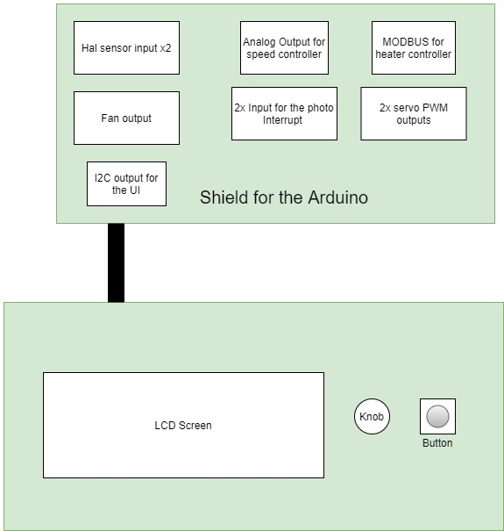

**Figure 13.** PCB layouts

**Table 1:** Bill of materials listing all components needed broken up into three main sections

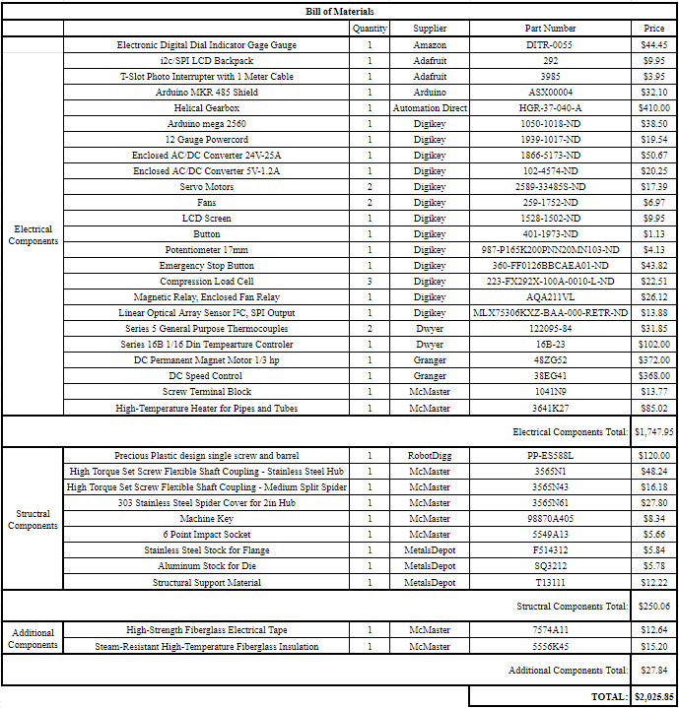

## References

[1] “The 3D Printing Waste Problem” *Ravi Toor*. [Online] Available: https://www.filamentive.com/the-3d-printing-waste-problem/

[2] “Polylactic Acid” *Wikipedia.* Available: <https://en.wikipedia.org/wiki/Polylactic_acid#Physical_and_mechanical_properties>

[3]”Polyethylene Terephthalate” *Wikipedia.* Available: https://en.wikipedia.org/wiki/Polyethylene_terephthalate

[4] “Too Hot to Handle?,” *Johns Manville*. [Online]. Available: <https://www.jm.com/en/blog/2015/february/too-hot-to-handle/>. [Accessed: 21-Oct-2020].

[5] “Precious Plastic design single screw and barrel for extrusion machine,” *RobotDigg*. [Online]. Available: <https://www.robotdigg.com/product/1719/Precious-Plastic-design-single-screw-and-barrel-for-extrusion-machine>. [Accessed: 21-Oct-2020].

## 

## Appendix A: ASA

<https://drive.google.com/file/d/1EE65yJVjCdfXfMbG0LArqNabjq12EPyd/view?usp=sharing>

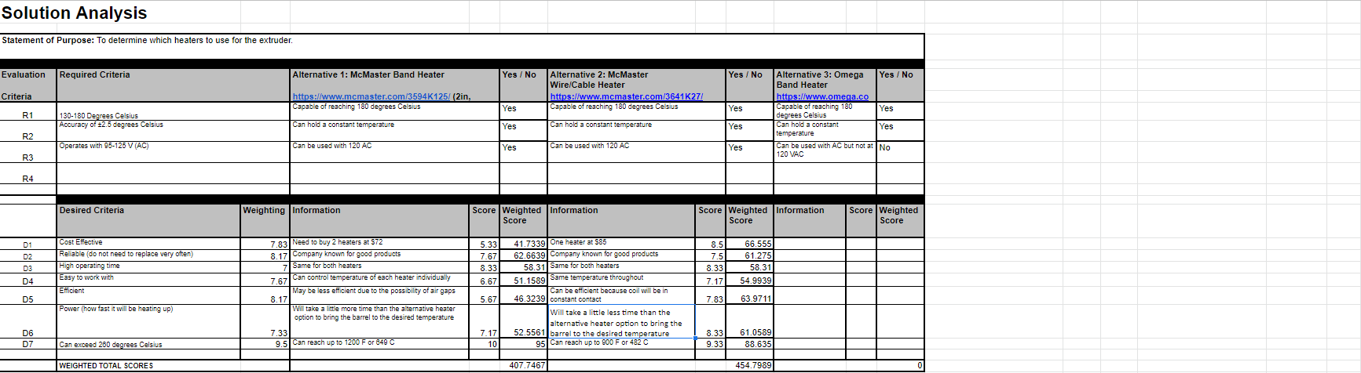

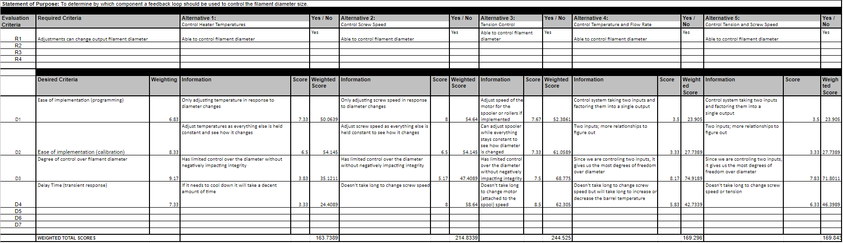

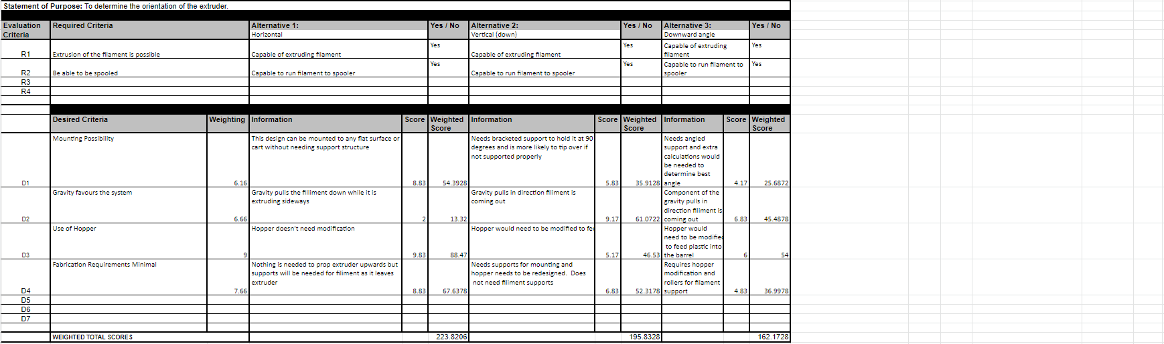

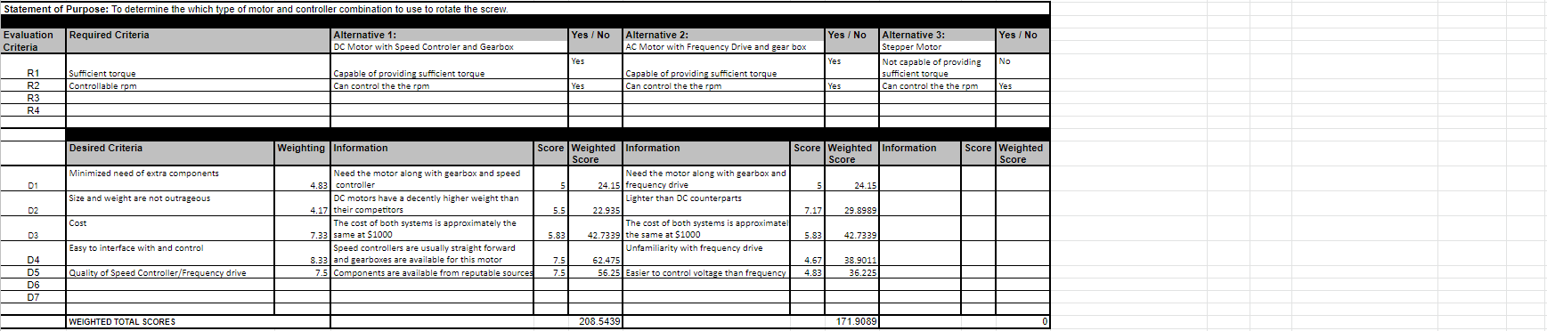

## Appendix B: Heat Transfer Calculations

**Table 2.** Heat transfer calculations to determine temperatures of the system under maximum load

|  |  |  |  |
| --- | --- | --- | --- |
|  | Temperature C | Diameter | Thermal Conductivity (k) |
| inner tube | max180 (reach goal 260 C) | 26mm =.026m | 16.26 W/(m*K) |
| outer tube | 177.4429061 | 34mm =.034m | 16.26 W/(m*K) |
| inner insulation | 177.4429061 | 52.61mm=.05261m | .0450 W/(m*K) |
| outer insulation | 50.1497723 | 121.79mm=.12179m | .0450 W/(m*K) |
|  |  | (38.1mm thickness =.0381m) |  |
|  |  |  |  |
|  | Power output maximum(W) |  |  |
| Wire heater | 500 |  |  |
|  |  |  |  |
| Length | 540mm =.54m |  |  |
|  |  |  |  |
|  | Convection coefficient (W/(m^2*K)) |  |  |
| air | 5 | (2.5-25 range) |  |
|  |  |  |  |
| Calculations |  |  |  |
|  |  |  |  |
| R1: | 0.004862739597 |  |  |
| R2: | 4.923426659 |  |  |
| R3: | 0.9727395008 |  |  |
|  |  |  |  |
|  | Celsius | Kelvin |  |
| Touter: | 177.4429061 | 450.4429061 |  |
| Tambient | 25 | 298 |  |
| Text: | 50.1497723 | 323.1497723 |  |
|  |  |  |  |
|  |  |  |  |
|  |  |  |  |
|  |  |  |  |

## Appendix C: SDRD

**Goal Statement**

The open-source filament recycler is a machine that will take ground up plastic and melt it down to extrude it into a usable filament for a 3-D printer to be used as an educational tool for school age children.

**Objectives**

In order to achieve success, the system shall:

1. Be able to move to various locations
2. Have a User Interface to control the system
3. Meet OSHA safety requirements
4. Have documentation for open source
5. Be tested to find optimal settings for different plastics

**System Requirements**

1. Electrical Systems
   1. The system shall be able to use an input between 95-125 VAC or 195-255 VAC at 60Hz.
2. Mechanical System
   1. The system shall fit in a cuboid with dimensions of 82 inches by 50 inches by 46 inches.
   2. The system shall have an in-house sensor to measure the output filament diameter.
3. Filament
   1. The barrel nozzle shall maintain a temperature accuracy of ±2.5℃ from the set value.
   2. The output filament diameter shall be 1.75 ± 0.05 mm.
   3. The filament shall be extruded onto a nominally 1 kg spool.
   4. The system shall accept shredded plastic with no dimension exceeding 7 mm.
   5. The system shall be capable of extrusion at a rate of at least 0.2 kg per hour.
4. Safety

4.1. The system shall cut off power within 1 second of using the emergency stop.

4.2. The system’s mechanical components shall stop within 5 seconds of using the emergency stop.

4.3. The system shall be built such that external surfaces that can be touched will not exceed temperatures of 49℃.

4.4. Any opening of the system shall comply with Table O-10 of OSHA 29 CFR 1910.217(c)(2)(i)(a) and 1910.217(c)(2)(i)(b).

1. User Interface
   1. The system shall maintain storage specified settings even after power loss.
   2. The system shall allow for manual temperature control between 130 and 180℃.
   3. The system shall allow for manual flow rate control between 0.1 kg and 0.2 kg per hour.
   4. The system shall display the current temperatures of the nozzle.
2. Budget
   1. The budget shall not exceed $5,000.
3. Documentation
   1. A bill of materials shall be included in the documentation.
   2. Mechanical drawings shall be included in the documentation.
   3. Electrical schematics shall be included in the documentation.
   4. Wiring diagrams shall be included in the documentation.
   5. Source code shall be included in the documentation.

The estimated cost of meeting the above requirements will be $2000.

1. Reach goals:
   1. For an additional $30 a scale shall be implemented to measure the amount of filament on the spool. The total weight of filament will be displayed on the user interface.
   2. For an additional $20 a distance control option shall be added to the control module. This will allow the control panel to be moved up to 15 feet away from the print but still attached with a cord .
   3. For an additional $20 the hopper size shall be able to hold 1 kg of shredded filament.
   4. Laser Micrometer at exit to determine filament diameter at an additional price of $1500. This will provide the current diameter of the output filament on the user interface in place of the in-house sensor specified in 2.2

## 

## Appendix D: Mechanical Drawings

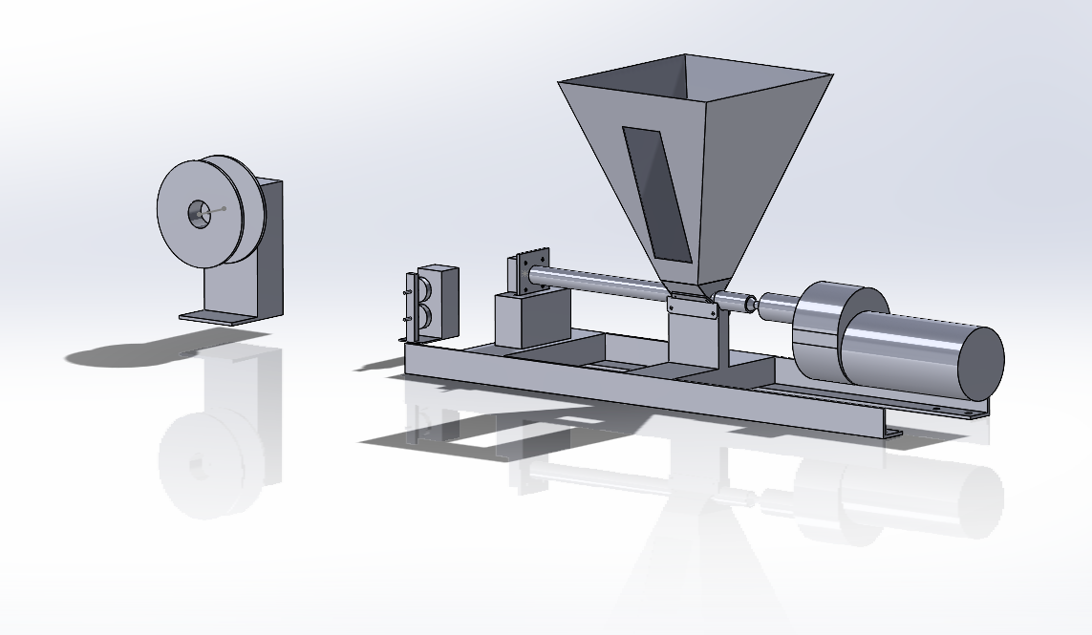

**Figure 14.** Final assembly

## 

## Appendix E: Wiring Schematic

The following figure on the next page shows the connection of all the sensors, the UI and the controllers for the heater and motors. This will be incorporated into the wire organization too. For a high resolution view see here: <https://github.com/jbayert/ValpoFilamentRecycler09/blob/main/Schematic/Schematic.pdf>

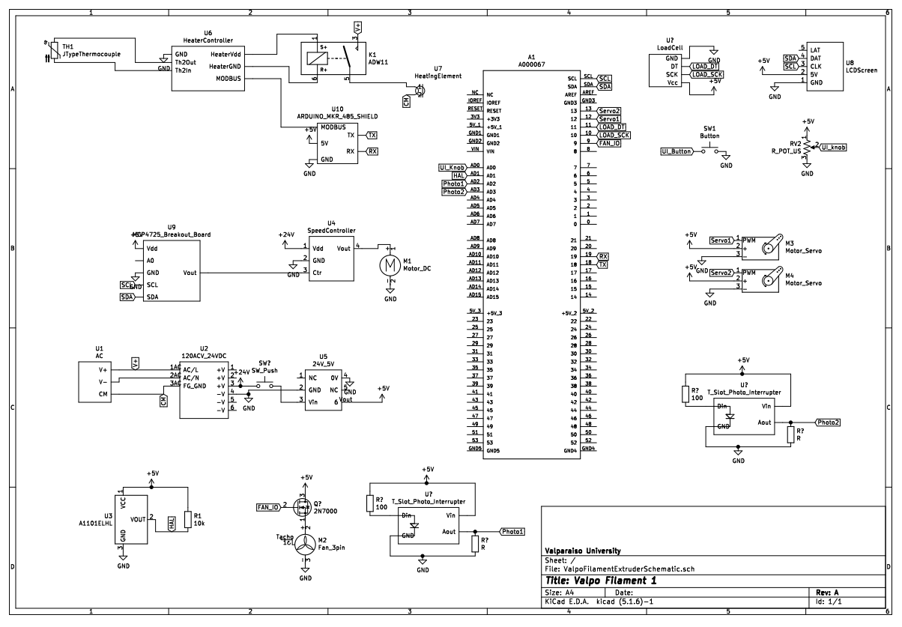

**Figure 15.** Electrical wiring schematic

## Appendix F: UI Operating Procedure

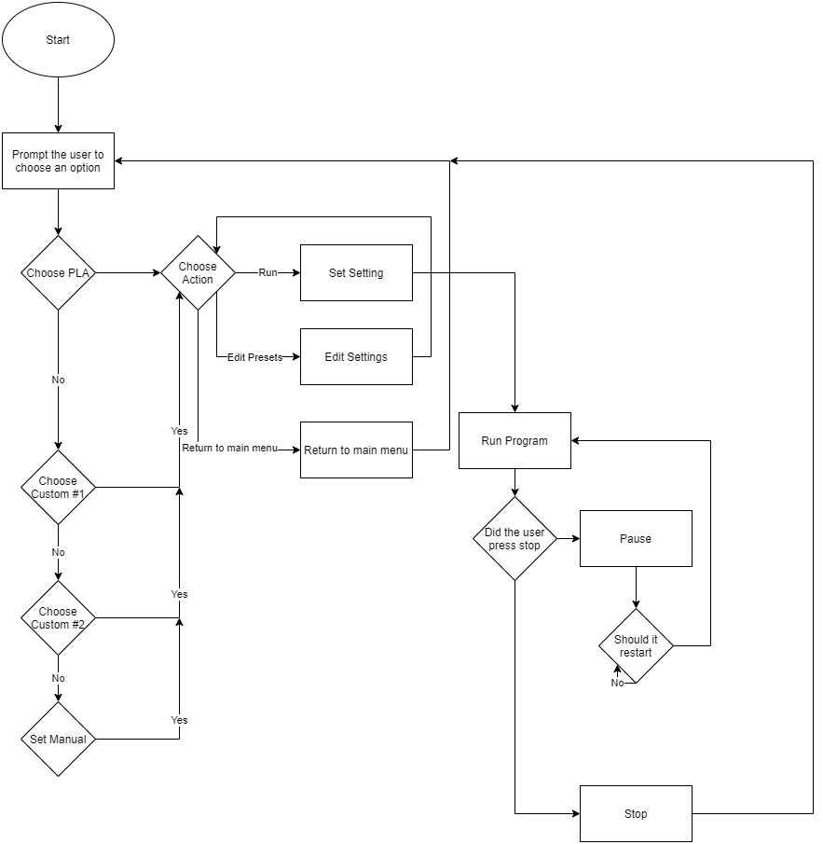

**Figure 16.** A typical operating system for the operating of the UI.

## Appendix J: Hazard Analysis

<https://docs.google.com/spreadsheets/d/1ko8Q23uOmE7hf15oV4E7Wg1MTEM90zofAZn5aAZxWAs/edit?usp=sharing>